Integrating an Open Source LMS into the traditional Educational Process*

GEORGOULI K., KANTZAVELOU I., SKALKIDIS I., ZAHARIOU P.
Department of Informatics
Technological Educational Institute of Athens
Agiou Spiridonos, 12210 Egaleo
HELLAS

Abstract: - The aim of this paper is twofold: firstly to present different ways of adopting and expanding an open source Learning Management System (LMS), to facilitate learning and educational processes in the Department of Informatics of the T.E.I. of Athens and second to present the results of an evaluation which has been conducted in order to investigate students’ attitudes created by the use of the LMS adoption.

Key-Words: - Open Source e-learning platforms, LMS, CMS

Introduction
E-learning platforms have paved the way to changing the existing ways of teaching and learning methods. Moreover, the demands on higher education require a fundamental change towards new technologies. While teachers might still be highly effective with the traditional lecture-style instructional method, most of them start feeling that they must attempt to stay up-to-date to technological advances, adapting to a more technology oriented teaching style, although this takes commitment and time [1].
Content management systems (CMS) and Learning Management Systems (LMS) that try to deal with the problems mentioned before, come in many different forms and scales ranging from complete university administrative systems to smaller systems that may be employed by course managers for individual courses [2]. Important parameters to choose an e-learning platform will of course be the flexibility and user friendliness of the systems, the ability to incorporate other media components, including interactive components and not the least the availability of systems which are developed using the open source technology. The choice of scale of content management to support higher education may be related to the degree of centralization of decisions. Universities that rely heavily on centralized decisions and common IT strategies may be better of with a large system whereas decentralized activities may find smaller and more flexible systems more beneficial [3].
At the spring semester 2004, the Department of Informatics of the TEI-A, adopted CS E-Class (http://eclass.cs.teiath.gr), an open source E-learning platform, aiming at the educational innovation and optimisation. The work was funded by the Greek Operational Programme for Education and Initial Vocational Training (O.P. Education). CS E-Class is the Greek version of the open source LMS Claroline (http://www.claroline.net), after been translated and provided by the Greek University Network (GUNET) to the Greek higher educational society.
CS E-Class open source e-learning platform has been proven a valuable, extensible, versatile and powerful tool that can assist in many educational tasks in our department. Initially, the lesson plan has been very seriously re-thought in order to see where technology can be effectively integrated. The transition from traditional lecture style to a more technology-based format was not difficult because the relevant course material was already prepared.
CS E-Class is a learning environment similar to most of the existing environments aiming mainly at the management of the educational content. The environment allows teachers to create and administer online courses. The main features that are offered in each course are the following (a) document repository in which lecture notes and relevant documentation can be stored and organized in folders (b) facilities for posting announcement online and uploading the course agenda (c) assignment area in which the professor posts assignments and students have to upload their reports to them by a specific date (defined by the professor). After a report is uploaded the professor can send feedback to the student in the form of comments and grades posted online (d) online self-evaluation tests. These are multiple choice or yes-no questions created by the professor using the tool provided by the platform. The students can test their knowledge in a given topic through them (e) group management. The students can be organized into groups each of which have a private document repository, forum and can be easily managed by the professor (f) forums (g) chat.
At the beginning of its implementation CS E- Class has been used as a supplementary tool of the in-class lectures by posting course announcements, homework assignments, lecture notes and other educational material. Although its main use remains the educational content management, further to that, different educational scenarios have been designed to carry out traditional lecturing in labs more effectively, as well as additional embedded or collaborating software has been developed to support traditional educational processes.
More precisely, a number of educational scenarios have been designed in order to use CS E-Class for out-of class information, educational content repose and retrieval, and in-class information during course lecturing. More sophisticated scenarios of CS E-Class use have been designed in order to support labs [4]. Three are the main issues concerning laboratories operation: registration to lab groups, in-class training, assignments uploading and exams. All the above need a very good organisation and scheduling in order to be accurate and not time-consuming and in all cases the support offered by the functionality of the platform has been proven very efficacious.
At the end of last semester, a questionnaire was delivered to the students of four different courses who have been asked to express their satisfaction or their discomfort of the already implemented innovative educational processes supported by the CS E-Class. From their answers the existing problems have been investigated in order to design more acceptable educational scenarios for next semester.
Extra functionalities have been added to the platform to provide missing tasks. The most important of them is the new Labs Management functionality, which was built especially for labs support. In this new environment the lab instructor is mainly able to handle the participation of each student at the lab (which is strictly determinate) and the marking of assignments and exams in a more efficient way.
Additionally a Graduation Theses Management System has been built specifically for the publication and control of the final-year theses. Each tutor can publicize a topic for a potential thesis; he can receive messages, assign a thesis to one or more students, grant access to specific users, monitor their progress, and finally publish it as a completed thesis for reference.
In the rest of the paper the next section will present the scenarios we used to support traditional lecturing and some statistics concerning the levels of adoption of the platform until now. In the third section we will present how the extra functionality of Labs Management has been designed and embedded in CS E-Class. In the fourth section we will present some issues concerning the Graduation Thesis Management System. In the fifth section we will present our deducting comments from the questionnaires filled up by our students and finally we will end up with our conclusions and future work.

Scenarios to support traditional educational processes
Support of traditional lecturing was always a significant part of the teacher’s work. The professor would have to give notes of his/her lectures, correct all the assignments s/he would give and prepare all the quizzes and exams s/he wanted. However, recent technological innovations in e-learning can help professors better organize their lectures while reducing their preparation time.

Applying for registration
Uses of innovative e-learning technologies are proved very helpful for the registration of students to their courses and laboratories. So far, in order for the students to register to their laboratories the professor had to announce the date, and time and place a message to the announcement board. On the arranged time the students (usually more than 100) should line up and wait until they register to the desired group of laboratories. This process was time consuming as well as disturbing for both professors and students. By introducing the CS E-Class registration this frustration vanishes. This type of registration was introduced the two preceding semesters with efficiency and satisfaction, making it a great success. The professors posted a notice on the website, announcing the time the laboratory groups will be available for registration. S/he created the different group hours of the laboratories and the only thing s/he had to do was at the time s/he pre-announced just to press a button that allows the students to register. The students only had to log into their account instead of standing on a queue, using a personal computer with an internet access, any time from that time on and register to the laboratory. When the process of registration is over, the professor had automatically a complete list of students for each laboratory group, with all their specifics (first and last name, student ID and e-mail, etc). It is also proved easy to manage the different groups that can be created, whenever a change is needed (i.e. a transfer of a student from one group to another).
The advantages of this electronic process successfully address the issues of time efficiency, frustration minimization and time independence, since it is not easy for everyone to be present at the registration appointment. Students favored this kind of registration and actually requested that this way should be expanded for the registration in all other courses.

In-Class training
During a course, course material is needed like lecture notes, exercises, announcements, and supplement educational material.
Using the CS E-Class the teacher can perform a variety of pop quizzes. He creates an exercise using the user friendly interface and each student that logs into his account, has to answer the multiple choice questions and his score is automatically calculated.
All the documents of the course, including lecture presentation, notes, sample exercises, even the schedule used for the laboratory are stored in the documents section, organized using folders, and are available any time to be accessed by the students. Thus, instead of handing out photocopies, diskettes or CD-ROMs, all needed materials and documents are transferred via the internet. Whenever there was a need for additional notes, the professor was uploading all his/her notes to the CS E-Class and the material was instantly available to the students. It was immensely helpful for the students to have all their studying material organized without having to look out for hardcopies and notes.
A very useful tool is the agenda module where the details of what has been discussed in every lecture is stored or announced.

Out-of-Class assignments and exams
A pivotal issue for the students to get familiar with what they are taught in class is the home assignments. Traditionally the teacher hands out the assignment and during the next course the students return their work. The teacher has to get through the hardcopies and sometimes has even to type some code in order to test the correctness of the exercises, and by the time he corrects them to hand them back to them. Using the CS E-Class though, the process has been remarkably simplified. The instructor put the assignment onto the system under a deadline. The students read the assignment, and when they completed it, they uploaded it to the system being then available for correction by the instructor. The instructor had the option to download all assignments delivered by the students on a zipped file, or one by one. So s/he had everything in an electronic format and the process of revising, grading and giving up comments was proved a much easier process. The students were able to see ubiquitous and at any time their grades and the comments on the mistakes made. The students really liked the efficiently, friendly and fast way of delivering their assignment, since they did not have to print anything, or buying electronic material (floppy disks, CD-ROMs). At the end of the semester they could review all their assignments, easily and altogether, but if for any reason they had missed a deadline and they had given their work either by e-mail or directly to the instructor, they could not see their work on the system.
The examinations had been processed in a similar manner. On the time of the exam the instructor “uncovered” the examination and in the given time the students answered to the questions. When they have finished, they uploaded their work and in this way they finished the examination. The instructor, in a similar way with students’ home assignments, corrected the examinations and the students viewed their grades along with remarks on their work.
In order for the students to be up to date with the newest scientific updates a links section exists, where the professor, aiming at better assisting the students on their assignments or their theoretical bases, publishes useful hyperlinks.
Traditionally, whenever an announcement had to be made, the professor was posting it on the announcement board. However, with the new system the announcement section of the CS E-Class through which e-mails can also be sent to selected groups of students, the students were informed of special lectures, cancellations of classes or any other issues that are important for them.

Present Situation
At the end of winter semester the situation concerning the use of the platform was in the following:
a) More than 90% of the main courses have on-line pages. Most of the compulsory courses don’t.
b) All of the on-line courses have uploaded documents in the form of notes or slides.
c) Only half of the on-line courses used the agenda facility and about the same percentage systematically put announcements on the platform.
d) The group facility seems not to be very well understood by the instructors and only 40% of them used it for lab grouping.
e) The e-application for registration to a lab group, while announced as an alternative possibility to the traditional applying process was warmly adopted from most of instructors who have adopting group facility.
d) The possibilities of the platform to support the laboratory in-class and out-of-class assignments and also running in-class lab exams have not been fully explored from the majority of the instructors.
Even if the above presented results are not totally satisfactory, at the time this paper was written the results have semantically changed toward a clear increase of all percentages.

Add-in Labs Functionality
Studies at the Technological Educational Institutes (T.E.I.) differ essentially from those at the Higher Educational Institutes (A.E.I.) because of their technological character supported by the mandatory attendance of the laboratory part of each course. The traditional way for an instructor to organise and run the laboratory is to decide first the approximate number of the required lab groups, then to ask from the students to appear and register to the group they want, to prepare exercises for in-class practicing and assignments for out-of-class work. At the end of the semester he usually has to prepare lab exams. At the same time he has to track the attainment of each student and to mark his/her delivered work.
The majority of LMS are not designed to support such a process and CS E-Class is not an exception. Even if it can be used to solve some of the management problems there are still needs that cannot be satisfied.
In order to solve this problem, having in mind to support as much as possible the instructors, we added into the platform a new functionality especially for the management of the labs.
To achieve this we added functionality in different levels:

- Added Functionality in Course level: a new link to a new environment for lab support has been added.

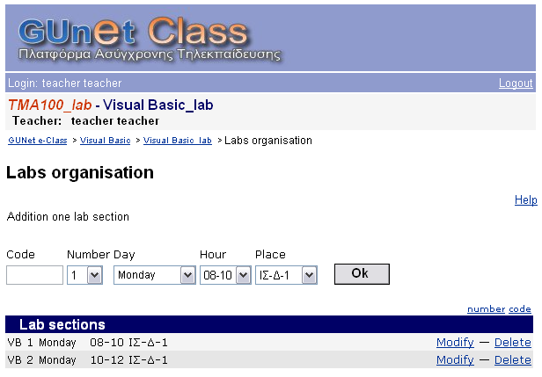
Fig.1 The Labs organisation
- Added functionality in Group Level: additional information has been added in this level to permit the instructor to note that students work in teams.
- Added functionality in Assignment level: in this level the interface permits to the instructor to define the weights for the final lab marking and to be informed about the grades of the students of each lab group. Also, excel sheets containing the students’ markings can be produced in order to be saved in another storage.

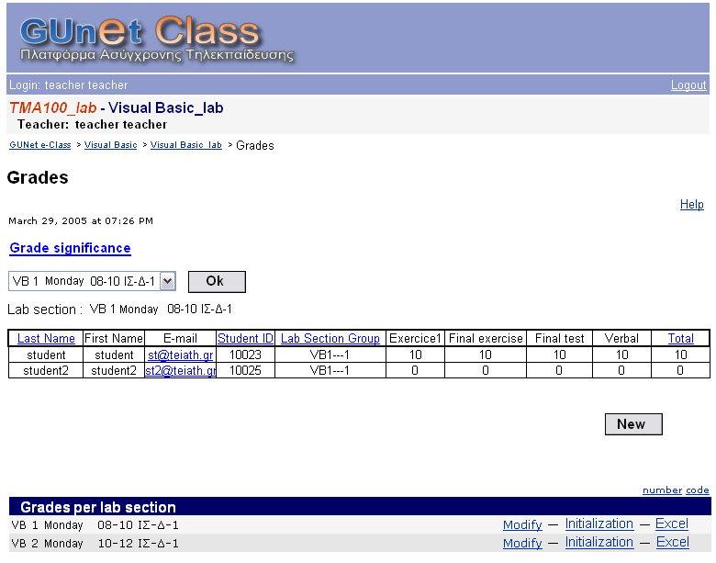

Fig. 2 The Grading environment
- A totally new functionality for the management of the students’ attendance has been added to the platform. Here the instructor can check the student’s presence in a table containing the names of the students of a group. The columns of this table concern the specific dates when the lab has been realized and are dynamically produced.
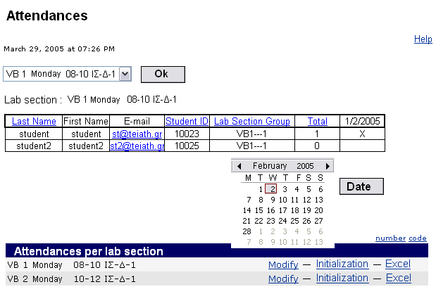
Fig.3 The Students’ Attendance environment
The new version of the platform is still under test and will be offered to the academic community at the beginning of the next semester.

Graduation Theses Management System (GTMS)
Trying to support better the academic community and at the same time to take as much as possible advantage of CS E-Class, we decided to build a Graduation Theses Management System (GTMS) solely for the management of the Graduation Theses of the Department, an independent system sharing the same users’ Database with the CS E-Class.
After the initial requirements analysis we decided to cover the needs of two categories of users, (a) professors who would like to upload and administer their students’ theses, (b) students who would like to have an easy way of browsing and searching for theses, and communicating with the supervising professors.
To build our system, first, web-design was chosen over client-server technology because of its simplicity of use and the ease with which one can access the application from any computer with an Internet connection and a conventional browser instead of client applications. Also, both professors and students of the department are already accustomed to such an interface. Our experience has taught us that users are difficult and unwilling to be educated in the use of new applications. So, we decided to keep things as simple and as close to the existing applications as possible, without sacrificing anything in the way of functionality. Lastly, our application should easily coexist with or be incorporated in the already existing web based applications or those which will be designed in the future, sharing their LDAP (Lightweight Direct Access Protocol).

Functionality of the GTMS
The system we designed is based on the three basic user types, the professor, the student, and the administrator. When a user visits the home page, he can login and perform tasks specific to his user type. The main functionality of the application though, which is searching for theses, does not require the visitor to be logged in.
Searching is practically the only action an anonymous visitor can perform. There is a set of ready queries by theses status (suggested, ongoing, to be presented). Additionally, an interface is provided through which one can search the database using a broad set of criteria that refer to almost every attribute of the thesis; from a drop down list of professors’ names, to supplying a keyword to be found in the thesis summary.

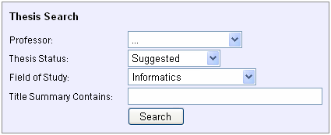

Fig.4 The Search screen

Additionally, the home page lists the theses we consider to be most interesting. Those would be the most recently posted and the ones that will be presented in the close future. Some short announcements/news are also available on this page. If the user wishes to accomplish specific tasks he can login to the system. Care has been taken to design the login page to prevent automatic logins using a security code and timing out the user after continuous failed login attempts in a short period of time. Let us note that the username/password used to enter the system are not stored in our applications database, because, both and most other user data is stored in the current LMS database and we have created a wrapper to access that data. This decreases our control on the application and relies on the other systems authentication methods; with all the advantages and disadvantages this may impose. However, it was considered more important to give the user a unique username/password set thus decreasing the need for administration of such data and simplifying things for the user and the Institution. At this point let us describe the different types of users and what each of them can and cannot do. Basically, there are three categories: the professors, the students and the system administrator.
(a) The professors. These are the most important users of our application. Considering the professors accounts are well checked before they are created in the LMS, so that no student or other person can get such an account and that the professors of the department are computer savvy and responsible; they have full administration rights for the thesis they create for their students or are part in. The whole idea of this Graduation Theses Management System is to put the power in the hands of well-informed and responsible users and let things run themselves. So a professor can create a new thesis and administer the ones he has already created. That includes changes made to the thesis description, setting the students who will work on it, setting start and presentation dates and uploading files some of which will be viewed by the public and some of which are private only to the professors and students that are working on the particular thesis.
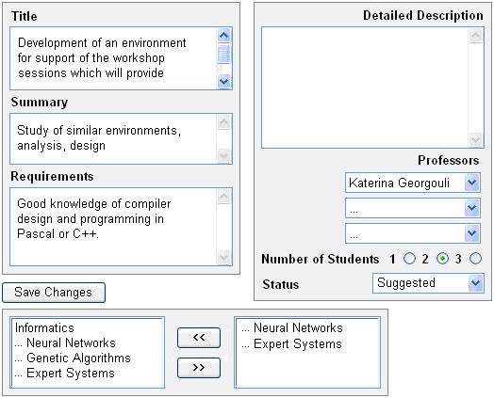
Fig.5 Create and manage a thesis

(b) The students. Students, on the other hand, cannot be allowed to have such rights. With that in mind there is only one thing they are allowed to do. Upload a private file for the thesis they are working on. Thus, the professor can delete it or set its status to public. There is no easy way, we can imagine, any harm can be done by the student-user.
(c) Despite the common practice we did not consider it necessary to give any special rights to the system administrator. The reasons are: a) it is not the administrator’s responsibility to manage the theses, b) the administrator doesn't need to manage users either because user management is performed strictly by the LMS administrator. To sum up, the system administrator can only upload news. This is also good if we want one person (a secretary or a student trainee) to simply upload news but have no rights to handle the database.

Questionnaire Results
At the end of last semester, we circulated a two pages questionnaire to students, who participated in the exams of four specific courses; ‘Introduction to Informatics’ (1st semester), ‘Compilers’ (5th Semester), ‘Artificial Intelligence’ (6th semester), and ‘Information and Communication Systems Security’ (7th semester).
Each questionnaire was related to one course, and it was handed over to students just before the beginning of the corresponding course exam. The students were not enforced to fill up the questionnaire, and therefore, we collected 392 questionnaires out of about 428 attendee students. As a result, our sample is 90% of the real number of attendees, quite close to the actual population.
Questions were classified into two sections; one section was related to the theoretical part, and the other section related to the laboratory part of the course. In the first section, various pieces of information were collected, e.g. semester of attendance, sex, part/full time student, etc., in order to categorize students and make the remaining information more valuable and sensible. In the following subsections, we interpret the results concerning five groupings of the questions.

The CS E-Class use
Questioning the ranking use of CS E-Class, 3% of the students never use it, 5% use it rarely, 67% when needed, and 25% use it frequently, as depicted in Fig.6.
It is noteworthy, that the above proportions are the same regardless of first or second time course attendance.

Fig.6 The frequency of the CS E-Class use

CS E-Class offers several facilities and tools, some of them supported by most professors and their Teaching Assistants (TAs). Questioning the use of the four most preferred CS E-Class facilities, the majority of students, up to 86%, use ‘the documents’, 54% use ‘the announcements’, 11% have accessed at least once ‘the course description’ to get a general idea of the course and its syllabus, and 10% use ‘the links’ to access relevant internet sites, proposed by the course instructor. Classifying the above results into two groups, one for first time attendees and another for second time attendees, the results show that the use of these four facilities decreases considerably, from 57% to 29% use of ‘the documents’ for each group, respectively. Similar outcomes for the other three facilities, deduce the conjecture, that students who attend a course for second time use CS E-Class 33% less, than those who are first time attendees.
The number of students who use other CS E-Class facilities, than the above mentioned, is insignificant, as well as the number of students who do not use CS E-Class facilities at all.

The CS E-Class material
The students believe that the material provided to support the four courses – notes, questions with answers, links, etc. – was carefully selected, sufficient and of good quality. In particular, 20% absolutely approve the material sufficiency and 27% the material quality, as well as, 53% and 48% respectively, state to some extent their agreement. No more than 8% complain about the material and approximately 17% do not explicitly express their opinion.
On the other hand, most students (73%) accept as true, that material acquisition considerably changed for the better, 33% totally agree and 40% almost agree, 6% have a different view, and 22% avoid having an opinion (Fig.7).

Fig.7 The material acquisition improvement

CS E-Class and the educational process
CS E-Class has been incorporated to serve the educational process. The focal point of this questionnaire is students’ answers when inquiring the degree of its improvement. Particularly, 15% stated positively that the improvement of the educational process is noticeable, and 42% believe that progress was made. Only 8% disagree partly, and 3% completely. Unfortunately, 33% do not clearly reveal their belief (Fig.8).
Correspondingly, 13% of the students answer that their participation was significantly strengthened when CS E-Class was introduced, 30% relatively have the same opinion, only 12% oppose to this, and 4% totally disagree. Unfortunately, 42% do not have a clear opinion about that.

Fig.8 The educational process improvement

Equally important was a question about the communication between the instructor and the student. The views of the sample seem to be equally divided. Students regard as true that they do not need any more as much contact time with their professor as before the use of CS E-Class, 8% are absolute on this and 24% just about agree. Conversely, 18% do not believe this and 14% completely disbelieve. However, 36% insist to refuse the disclosure of their thoughts.

The CS E-Class platform
CS E-Class is a user friendly and easy-use platform. Most of the students (61%) entirely accept this view and 27% admit it to a degree (Fig.9).

Fig.9 The easy to use CS E-Class

Certainly, a program is useful and functional when it is available. At the beginning of the CS E-Class installation and operation, several problems appeared and from time to time CS E-Class slowed down or even became unavailable. Questioning the CS E-Class availability, 33% think that it is available, 28% more or less available, but 13% answer that E CS E-Class denied some of its services, 6% denied all its services, and 21% express no comment in either direction.
Likewise, 32% declare that information download was absolutely speedy, 40% state that it was fast enough, 8% argue on this, and 3% do not agree at all.

CS E-Class and Labs
At the beginning of last semester, it was the first time we attempted also the use of CS E-Class to split up students into laboratory groups. For that reason, we announced instructions - especially for inexperienced students of the first year - and we successfully accepted their registrations to the laboratory groups, electronically in CS E-Class. Students acknowledged the success of this effort and characterized it as either perfectly effective (55%) or just effective (29%). Few students (8%) doubt this effectiveness and 9% stayed away from a position.
One of the main and most useful facilities of CS E-Class is the ‘Essays’ facility. The instructor and the TAs set a deadline for each of them and students are able to upload their essays and have to meet this deadline. After that, the TAs are able to read, save, and/or print students’ essays and mark them in CS E-Class. Grades are available to students individually. Commenting on the described procedure, 18% of the students assert that it increased their interest for lab activities, 29% have nearly the same opinion, 35% did not state obviously what they think, 7% did not really like this method, and 11% preferred the traditional circulation and submission hand to hand.
Additionally, 24% of the students say that the new method increased their homework time, almost 23% believe that their homework time stayed the same, 10% argue with this, 14% are at the opposite side, and 30% do not mention any change.
Furthermore, 19% of the students think that they became more consistent in keeping tough deadlines, 33% practically say the same, 12% did not actually become more consistent, 10% not at all, and 27% do not believe that the method has pros or cons related to their personal consistency.
Finally, at the end of last semester, lab exams were organized and carried out using CS E-Class. Questioning students if this examination system improved their scores, 17% entirely approved this examination system, 23% to some extent, 14% did not agree, 12% reject it, and 34% did not notice either better or worse scores (Fig.10).

Fig.10 The use of CS E-Class in lab exams

Conclusions
CS E-Class experience was probably typical for all institutions trying to make foundational changes in the traditional way to support education. Like most institutions of its size and position, TEI-A has limited resources, so the choice of an open-source e-learning platform was imperative. Such a choice was also beneficial for the students who were able to work on the open source code gaining experience and augmenting the functionality of the system.
Preliminary results suggest that the redesign of the educational process has been well received both by instructors and by students. More than 30 instructors have assumed responsibly for some portion of content on the platform, and those instructors are finding new and exciting ways to use it.
Concerning the CS E-Class material, we should focus on the material acquisition rather than the content of the material itself, and it is believed both by the instructors and students that the acquisition changed considerably for the better. The educational process showed a great improvement especially in the laboratories since the instructors have greater flexibilities when giving out class material, exercises and exams. The platform is considered user-friendly and this adds up to better adoptability.
The processes of splitting students in laboratory groups in a combination with the home assignments process are considered the biggest advantages of the platform and make them great motivation for the instructors to use the CS E-Class.
The effectiveness of the CS E-Class in the lab exams is considered a great success on behalf of the instructors.
The satisfaction of the use of this platform will increase semester by semester because the students will get familiar with it and the use will be much easier, since we know that moving into something new is a change that not everyone likes.
The added functionality in the laboratories management is expected to help mostly the instructor in organizing the teamwork, the attendance and finally to grading of the students in a more convenient way.
Concluding, Open-Source Learning Management Systems like CS E-Class, make industrial-strength content publishing and effective application of educational innovations possible, and in the future are likely to be regarded as an essential component of the business of being a university.

References:
[1] Weis E. & Efaw J., Using Blackboard, Instead of a Blackboard in the Classroom, In Proc. of IADIS International Conference Cognition and Exploratory Learning in Digital Age (CELDA 2004), Lisbon, Portugal, 2004, p.p. 149-156.
[2] Hunter Philip, "The Management of Content: Universities and the Electronic Publishing Revolution", Ariadne Issue 28, http://www.ariadne.ac.uk/issue28/cms/intro.html, 2001.
[3] Ribe L., Hansen S. & Dørup J., A content management system for higher education based on Open Source freeware, Eunis 2002 The 8th International Conference of European university Information Systems, 2002.
[4] Georgouli K., Grivas M., and Zahariou P., Different Uses of an Open Source LMS for Educational Support, “FACTA UNIVERSITATIS (NI ¡S), SER.: ELEC. ENERG.” vol. 18, No. 2, August 2005 (in press).

 * This work is co-funded by 75% from EU and 25% from the Greek Government under the framework of the Education and Initial Vocational Training II, programmes “Archimedes” and “Supporting the Informatics Studies in the T.E.I. of Athens”.

